DefendTheBase!

Manual

Game Overview:

In this game your objective is that you need to defend your base against the evil zombie aliens who want to destroy it.

You can defend it with all kind of towers and cut their root and destroy them before they can reach the base.

If you destroy one of them you get some money and some score with the money you can buy more deadly towers and you can register your score in the score table let’s see who will be the best zombie alien hunter!!!

First you have enough money to buy some low tier level towers but later you can buy a magical spell slinger zombie killer awesome one.

They are coming in waves in the first wave not too many but in the later stages they numbers are growing!

But beware if one of them reach the base it’s Hit point go lower one point if this point will be zero and you lose the game so be careful!!!

System requirements:

* Windows10
* 100Mb Free Disc space

Main screen:

This is the Main screen in the game.

With the new game button, you can start your game.

The score button brings you to the score screen where you can register your highest score.

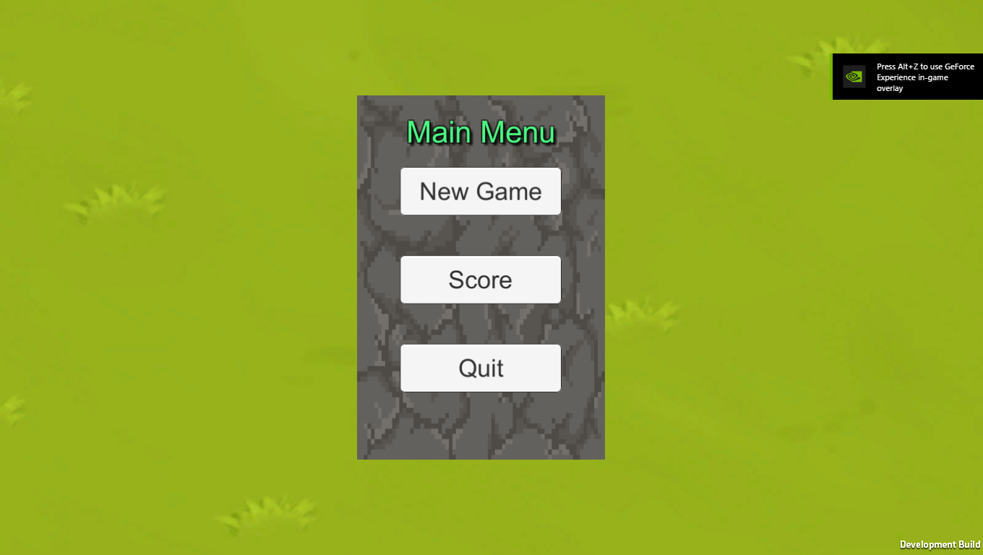With the Quit button you can close the game.

The Game:

In the game you can start the wave with the start wave button **BUT you first need to buy some towers too eliminate your enemies.**

**You can’t buy towers if the wave is active so be careful.**

The hearth is your base health if the number zero you lose the game.

After you defeat an enemy you get some money it is your resource with that you can buy towers.

(The number with the green $)

The wave meter shows your actual wave

And the score shows you how many score you get in the game.

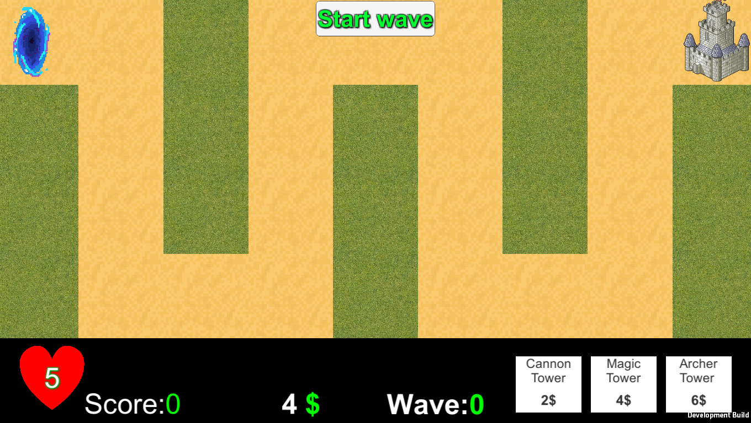

Buying and placing towers:

At the beginning you have 4 $ and you can buy some defense.

The down right corner you can find the purchasable towers with the price if you have enough money click the icon to buy one.

After that you can place your tower one of the green areas on the game field.

You can’t place a tower on the top of another it will show you a red field.

And you can’t place towers on the enemy rout.

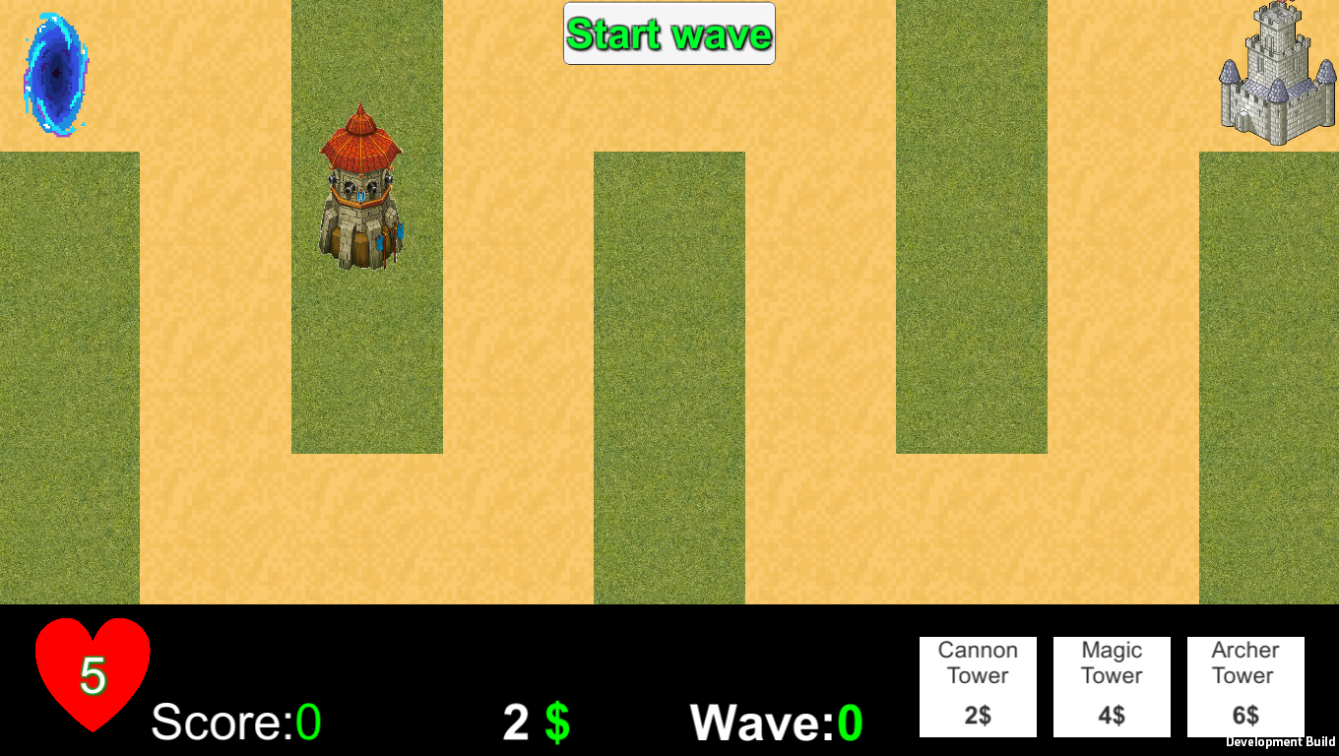

Tower Range:

All the towers have range. This show you is it can attack the enemies or not.

Click on a tower to enable the range and click a green area to disable the range.

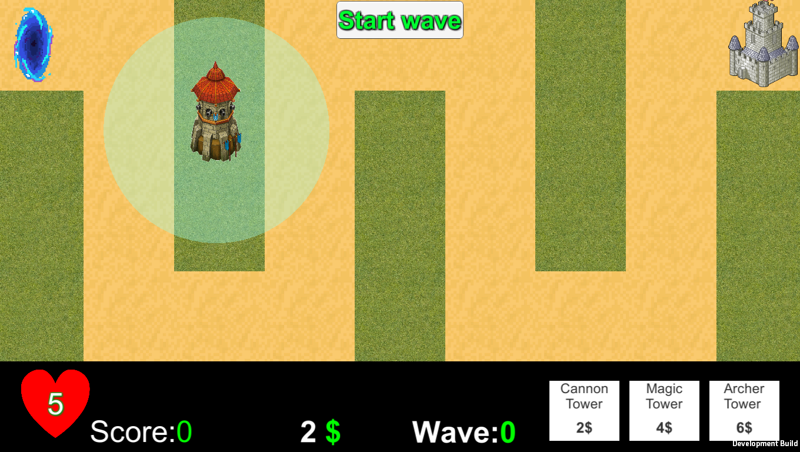

Starting a wave:

You have the towers so lets the fun begin!

Click the start wave button after a short time the first enemy spawning and start walking to your base.

If the zombie is in the tower range it starts shooting.

Every hit the zombie HP (Hit Point) reducing if the hp is 0 the Zombie dead and you get some money and score.

You can prepare yourself for the next wave **but don’t forget first buy towers!**

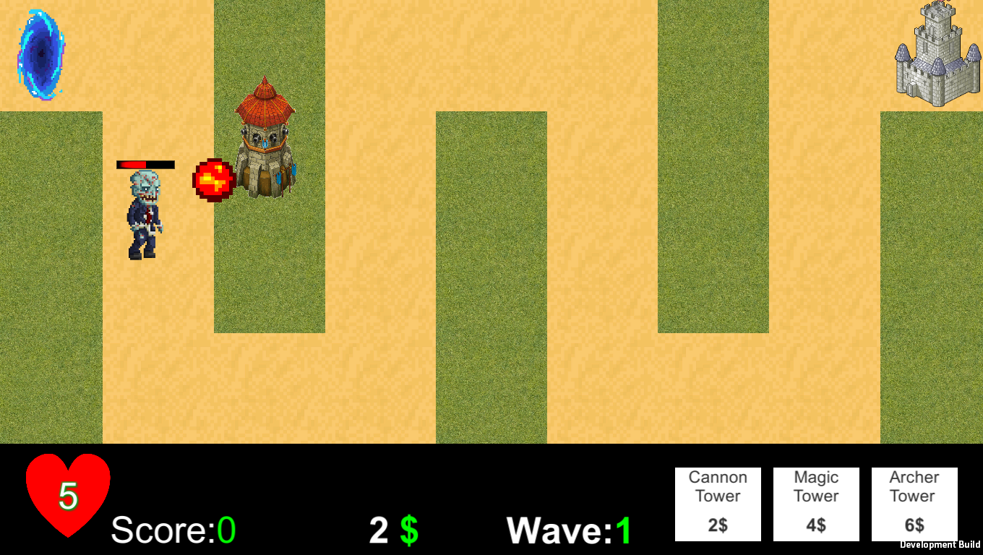

Score:

You can reach the score from the main menu

Here You can register your highest score and see which players have the best.



Esc menu:

In the game if you pressing the Esc button a menu will show up here you have option to go back the main menu, continue, restart the game or close the program.

